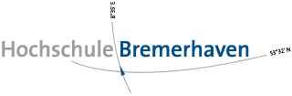 



FLOE NAVIGATION SYSTEM

ADMINISTRATOR GUIDE

RELEASE 1.0.0

DECEMBER 2018

Nadeem Gul

Rintu Daniel

Contents

Preface: i

Audience: i

Related Documents: i

1. Getting Started 1

2. System Overview 2

2.1 Coordinate System 2

2.2 Background Services 5

3. Accessing Administrator Dashboard 7

4. Setting Up the Coordinate System 9

5. Sync Server 16

6. Synchronization 21

7. AIS Station Deployment 24

8. Recovery 26

8.1 AIS Station Recovery 26

8.2 Static Station Recovery 28

9. Configuration 31

9.1 Parameters 31

9.2 Editing Configuration Parameters 32

10. User Administration 35

# Preface:

Welcome to the Floe Navigation Android Application. The application can be installed on any Android tablet (For the MOSAiC expedition the tablet being used is [XSLATE D10](https://www.xploretech.com/downloads/Marketing_Brochures/D10/XSLATE_D10_Specsheet_EN.pdf)). This application uses the periodic data from AIS transponders installed on the Sea Ice to create a coordinate system which is fixed on a moving ice floe. It creates a visual representation of the coordinate system in the form of a grid which can be used to navigate on a moving Sea Ice.

Please read through this document thoroughly before you start to use the Floe Navigation App. The purpose of this guide is to provide configuration and administration guidelines for the Floe Navigation Android App and the Synchronization Server.

## Audience:

This document is intended for the Administrators of the Floe Navigation System application.

Related Documents:

For more information, see the following documents:

* Floe Navigation User Guide
* Floe Navigation Developer Guide

# Getting Started

Please read through the following necessary and important configurations that need to be done in the Android environment to ensure the smooth operation of the Floe Navigation App.

* The App needs an AIS Transponder to run. Ensure that the tablet is connected to the Wi-Fi network of an AIS transponder.
* Make sure that only one Tablet is connected to the Wi-Fi network of an AIS Transponder, as the AIS transponders do not support multiple client connections.
* Make sure that the location on the Android device is enabled. For details visit [Android documentation](https://support.google.com/accounts/answer/3467281?hl=en).
* Make sure that the Tablet is not connected to any other network interfaces such as Ethernet/GPRS and only a Wi-Fi network of an AIS Transponder is connected.
* For smooth operation, it is recommended that there are no other apps running on the device when the Floe Navigation App is running.

# System Overview

Sea Ice is a continuously moving platform, and conventional mapping applications which are based on the Geographic Coordinate System (Latitude and Longitude) cannot be used on it. As a consequence of which there is currently no system in place to monitor the movement of people and equipment on the Sea Ice, store the location data for measurements/samples relative to the Sea Ice and create points of interest or waypoints on the moving Ice floe.

The primary aim of Floe Navigation System is to create a Coordinate System which can work with a moving Sea Ice and give any expedition which wants to work on such a platform to store location data (Geographic Coordinates as well as Relative Coordinates) for different sensor measurements which are be taken on the ice over the expedition period. Additionally, it provides a way to constantly monitor the movement of the personnel and equipment on the Ice. It also provides Safety information about the dangers, such as ridges or leads present on the Sea Ice; which enables the users to work in a safe environment.

To that end, the Floe Navigation System uses AIS transponders which should be installed on the Sea Ice to create the coordinate system. AIS is an automatic tracking system which makes use of the transponders installed on ships which transmit navigational information. Each AIS Transponder is also able to receive the information transmitted by other vessels in the vicinity. For more information visit [AIS info page](https://en.wikipedia.org/wiki/Automatic_identification_system).

## Coordinate System

The Floe Navigation System needs at least two AIS transponders to create the coordinate system which is formed by designating one AIS transponder as an origin of the coordinate system and another AIS transponder is used to mark the direction of the x-axis. The y-axis of the coordinate system is considered perpendicular to the x-axis. The AIS transponder moves with Sea Ice and broadcast their geographical coordinates periodically with the movement. As the Geographical coordinates are updated, the system recalculates the coordinate system and the position of all the objects (stations and other points of interest) marked on the coordinate system along with it.



Figure . Basic Coordinate System on Sea Ice

The Floe Navigation System projects the Geographic coordinate system on to a 2-D plane with Latitude along the y-axis and Longitude along the x-axis. The intersection of the prime meridian and the equator (0°, 0°) is the origin of the 2-D plane. The mapping is done in such a fashion that 1° along the latitude axis represents 60 Nautical Miles. Since the Earth is not a perfect sphere and longitudinal lines are closer together at poles and farther apart near the equator so 1° along the longitude axis represents 60 NM at the equator and as we move towards the poles the distance represented by 1° decreases by a factor cosine of the latitude. So, on the longitude axis, 1° represents 60 NM * .

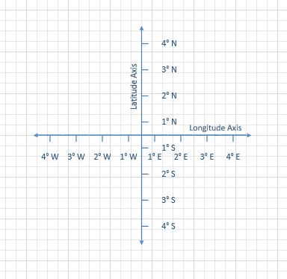

Figure . Map Projection

The mapping from the Geographic coordinates to the custom coordinate system is done by calculating the angle between the x-Axis (marked by the two AIS transponders installed) of the custom coordinate system and the Geographic Longitudinal direction. The angle of the custom coordinate system to the Geographic Longitudinal axis is called Beta angle denoted by β.

Every new Fixed Station (mounted with an AIS Transponder) that is installed is specified by its distance from the origin and the angle α it makes with the x-Axis of the custom coordinate system. A simplified version of this scenario is shown in Figure 2.3. The angle α and the distance for all Fixed Station are considered to be constant* and the angle beta can be recalculated from the constant α and distance from each Fixed Station.

The value of angle β is updated at regular time intervals (10 seconds) by calculating a new value from the location data received from each Fixed Stations and averaging it; so that if any of the Fixed Stations (including the origin and x-Axis marker) breaks away from the Ice, it does not affect the value of β greatly and the coordinate system persists. So, the coordinate system is independent of the Fixed Stations; as long as there are two Fixed Stations installed the system can function.

AIS Transponders which are not installed as Fixed Station are shown as Mobile Stations and for each of these mobile stations, the app calculates the angle α and distance at regular time intervals from the location data received from the AIS Transponder.

There are certain points on the Sea Ice which do not have an AIS Station mounted such as Static Stations or Waypoints. For these points, the system calculates the angle α and distance from origin using the tablet’s location at the time of installation. As these points are considered to be stationary on the Ice, these parameters are not recalculated again and it remains constant unless the point is recovered.



Figure . Coordinate System

## Background Services

As explained in Section 2.1 the app needs to calculate important parameters of the coordinate system and the points installed at regular intervals. To that end, the Floe Navigation App uses multiple background services which ensure accurate calculation of the coordinate system and its parameters. As administrators you are not responsible for the maintenance of the background services, however, it is useful if you are aware of the services the app uses and their respective functions. For more details about services implemented check the Floe Navigation Developer Guide. For information about Android Services check [Android Documentation](https://developer.android.com/guide/components/services).

Table . List of Background Services.

|  |  |
| --- | --- |
| **Service Name** | **Description** |
| GPS_Service | Responsible for reading the current location of the tablet and synchronizing time with the GPS Clock time. Runs every 30 seconds. |
| Network Service | Ensures that the app is connected to the Wi-Fi network of the AIS transponder and in case the connection drop tries to reconnect. |
| AIS Decoding Service | In case the app is connected to the Wi-Fi network of an AIS Transponder, this service is responsible for decoding the incoming AIS messages. Runs for every received AIS Packet. |
| Alpha Calculation Service | Calculates the angle α and distance from the origin for each mobile station. Runs every 10 seconds. |
| Angle Calculation Service | Calculates the angle β using the location of all the Fixed Stations. Runs every 10 seconds. |
| Prediction Service | Predicts new position of all the Fixed Stations using their previously received AIS data (location as well as navigation data). Runs every 10 seconds. |
| Validation Service | Checks the difference in the predicted (from the Prediction Services) location and the received location (from the AIS Decoding Service) for each Fixed Station. In case the prediction goes wrong multiple times the station is considered to be broken from the Sea Ice. Runs every 3 minutes. |

# Accessing Administrator Dashboard

The Admin Dashboard can be opened from the Main Dashboard of the Floe Navigation App. The Admin Dashboard can only be accessed with valid user credentials.

The Floe Navigation app is pre-configured with a default username and password.

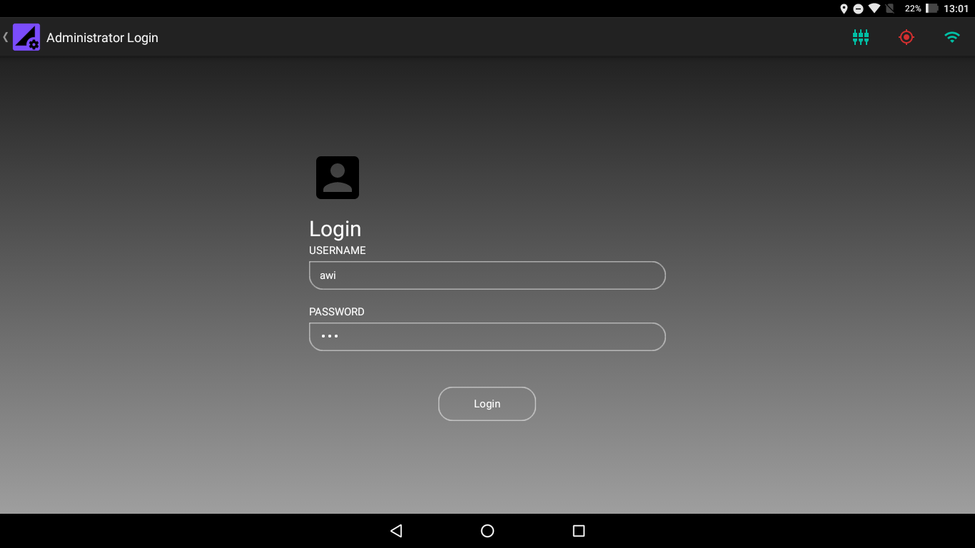

Figure 3.1 Administrator Login Screen

The pre-configured user credentials are:

Table 3.. Default User Credential

|  |  |
| --- | --- |
| **Username** | **awi** |
| **Password** | **awi** |

Refer to Chapter 10 for User Administration.

On successful login, the Administrator Dashboard is displayed.

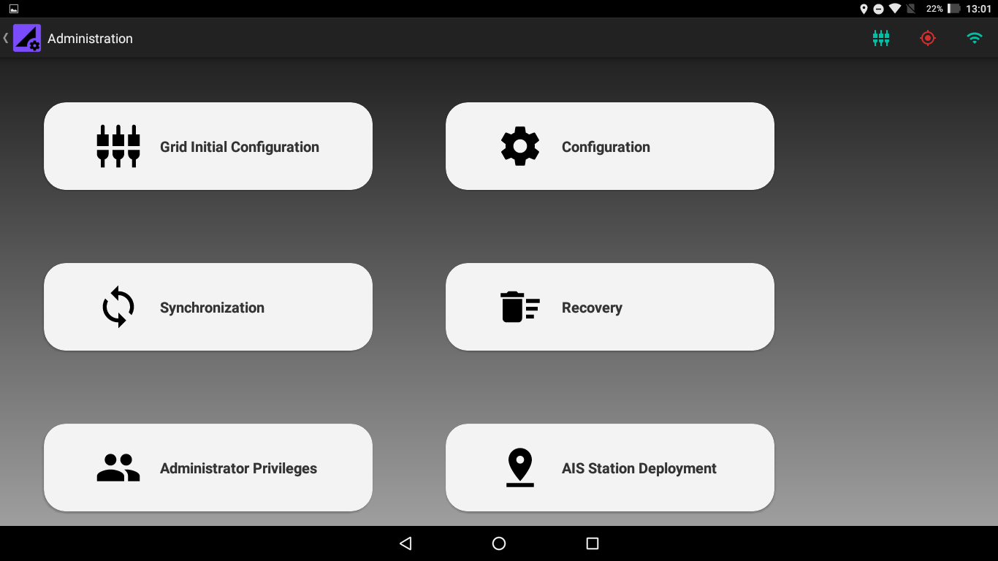

Figure 3.. Administrator Dashboard

# Setting Up the Coordinate System

The Floe Navigation system needs at least two AIS Transponders installed as Fixed Stations on the Sea Ice to create its coordinate system (For details about the Coordinate system check Floe Navigation User Guide Chapter 3). The coordinate system needs to be established on only one tablet and it can be replicated in the other tablets using Synchronization (Refer to Chapter 6 for details).

The coordinate system can only be established by an administrator and it is recommended that you set up the coordinate system immediately after installation of the app.

To start setting up the coordinate system access the Administrator Menu as described in Chapter 2. When accessing the Admin Menu for the first time the App will display a dialog box asking you to set a Unique Tablet ID for the tablet. This will be done only once, however, the tablet ID can be reviewed and reset from the Configuration Menu (Refer to Chapter 9). The Tablet ID needs to be set for each tablet separately.

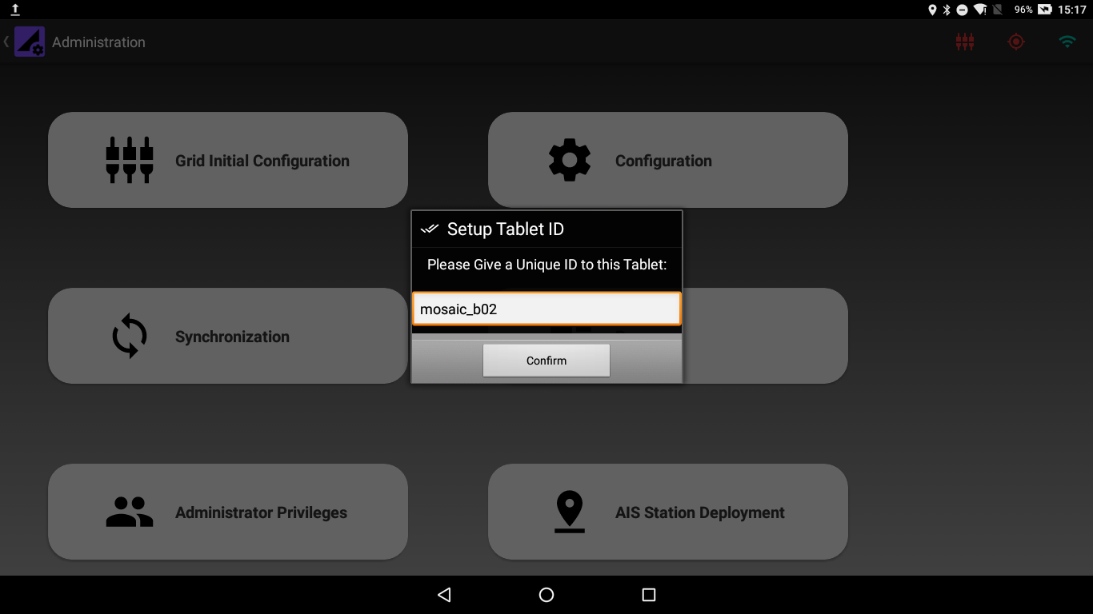

Figure . Tablet ID Dialog Box

Once the tablet ID is set, you can start setting up the tablet. However, it is highly recommended to check the value of the INITIAL_SETUP_TIME parameter in the Configuration Menu before setting up the coordinate system. The default value for the INITIAL_SETUP_TIME parameter is 30 minutes. For details about the Configuration Parameters check Chapter 9.

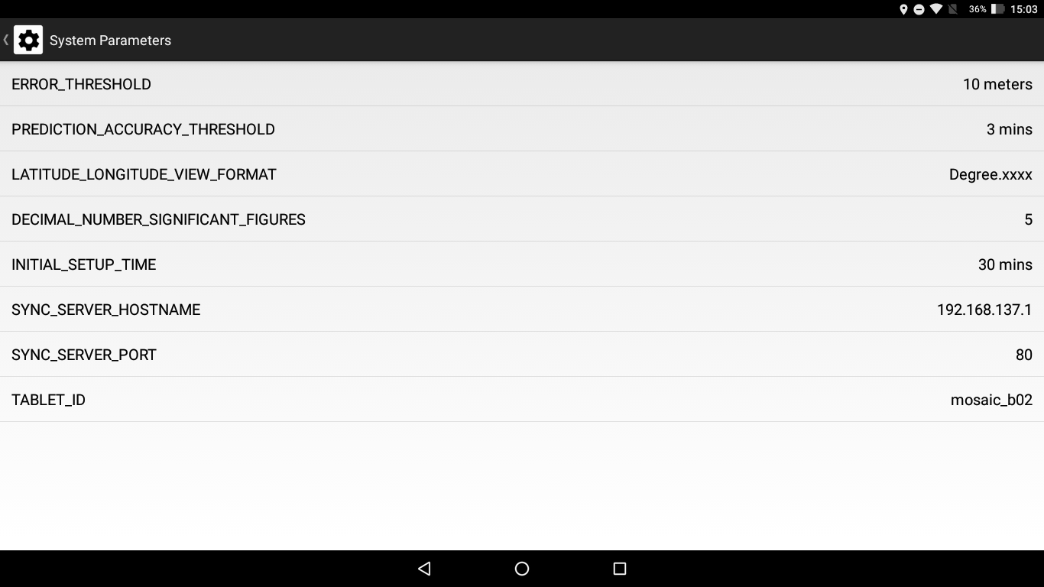

Figure . Configuration Parameters

To set up the coordinate system enter the Grid Initialization menu from the Administrator Dashboard and perform the following steps. **It is imperative that you perform the following steps in one go and do not close or minimize the app or press the back button, while the setup is in progress**:

1. Provide the Name and MMSI of the first AIS Transponder. Please note that the location of the first AIS Transponder will become the origin of the coordinate system.

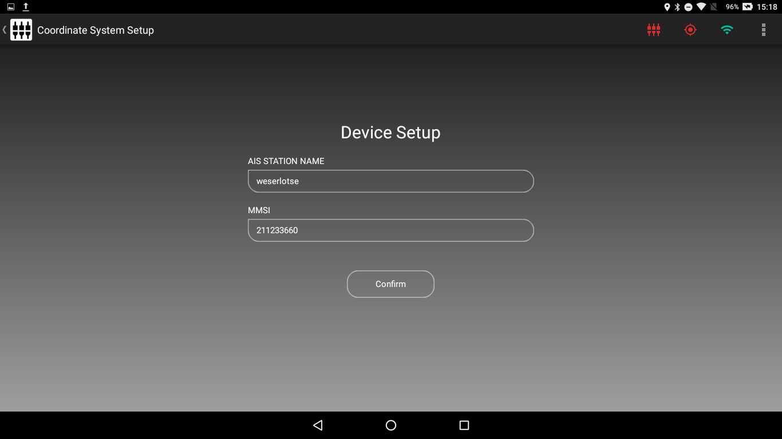

Figure . Setting up an AIS Transponder

1. If a correct MMSI number is entered and confirm is pressed the app will enter that MMSI number in its internal database and wait for a packet from the corresponding AIS Transponder.

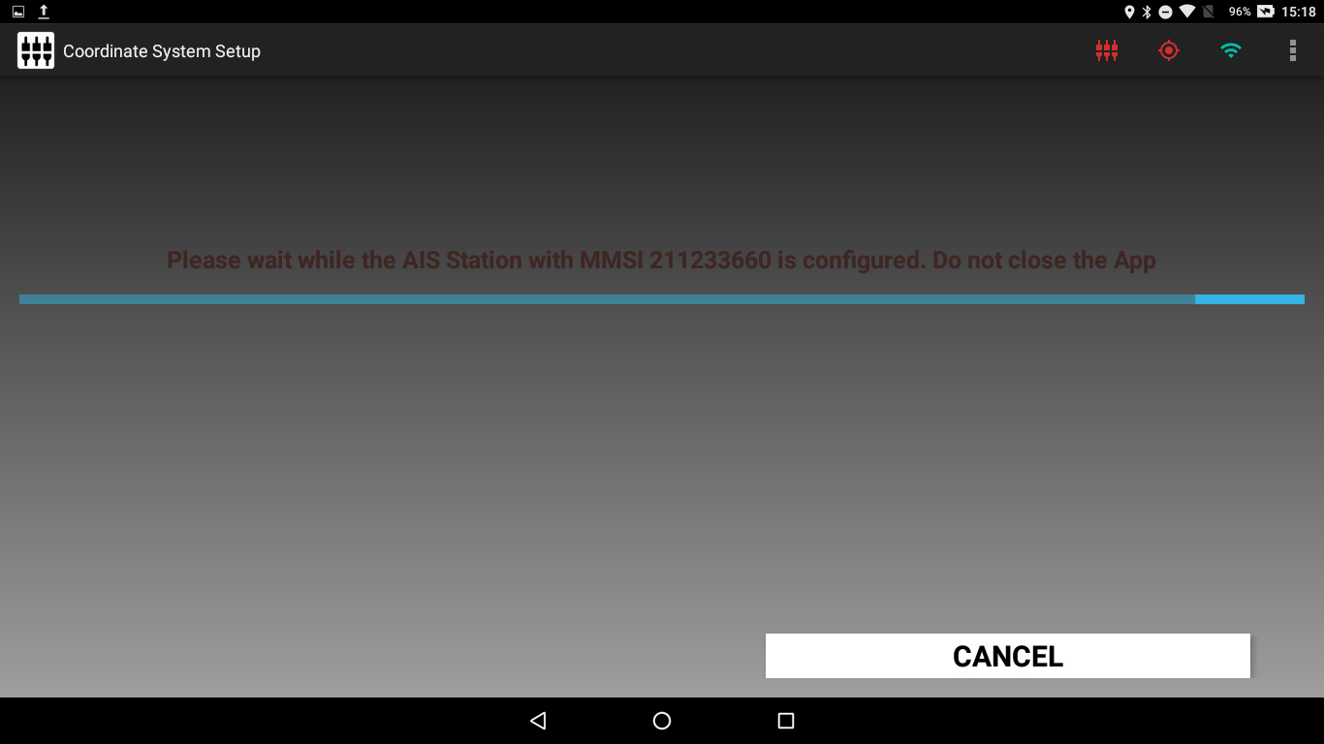

Figure . Waiting for an AIS Packet

If a packet is not received for 5 minutes or the cancel button is pressed the MMSI will be removed from the internal database and you will be redirected to Step 1.

1. When a valid packet with location data is received from the AIS Transponder the App will display the location details received along with the location of the tablet.

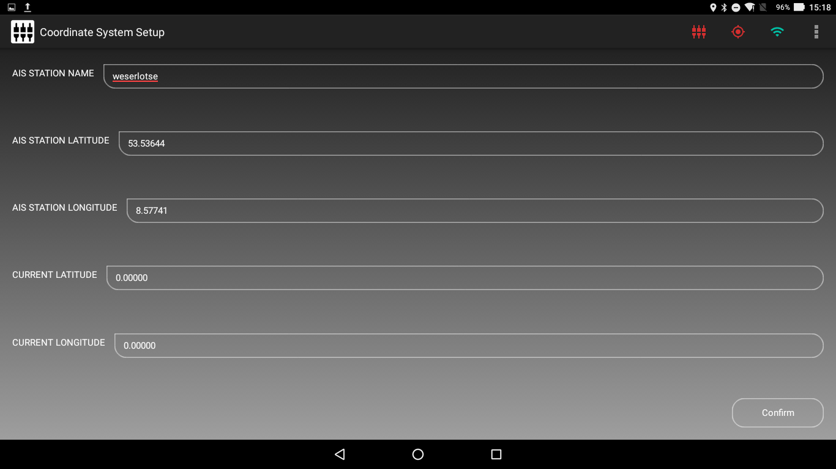

Figure . AIS Transponder Received Location Data

The format of the coordinates being shown on the screen can be changed from decimal to Degree (°) Minutes (‘) Seconds (‘’) using the Change Lat/Lon Format from the Action Bar.

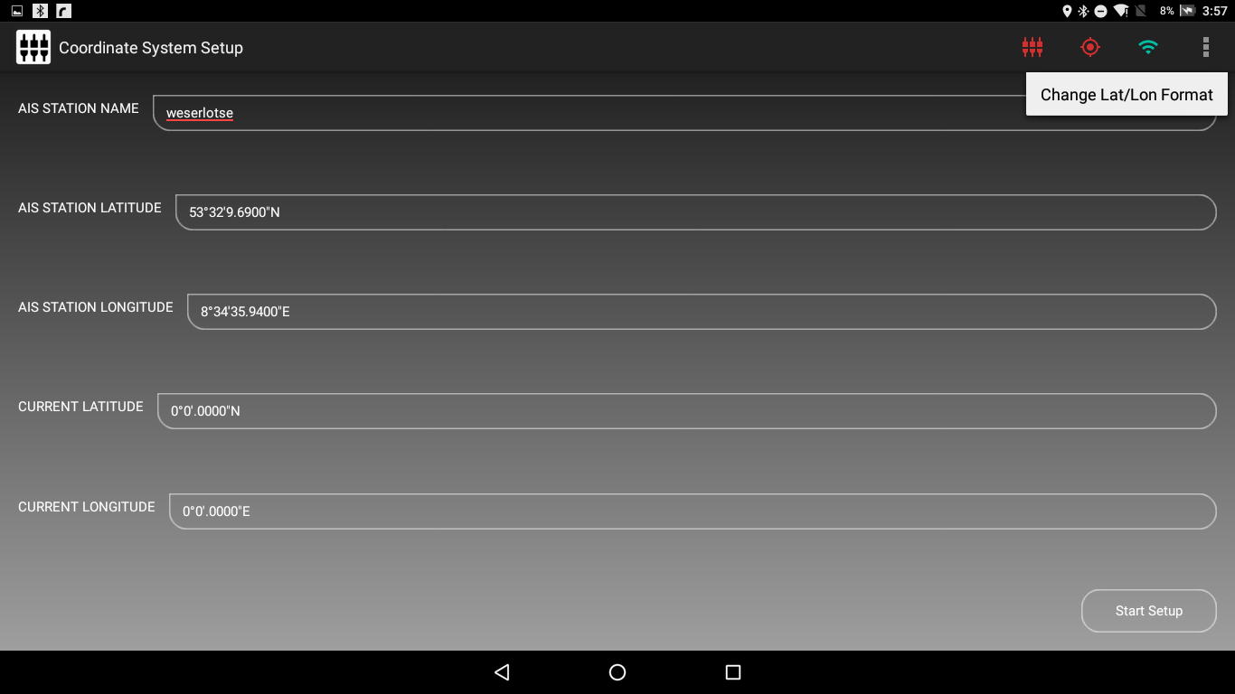

Figure . Change Latitude Longitude View Format

1. When confirm is pressed the AIS transponder is installed in the App as a Fixed Station.
2. Repeat Steps 1 through 4 for installing the second AIS Transponder which will mark x-Axis of the coordinate system.
3. When the second AIS Transponder is also installed, the app runs the Coordinate System Setup during which the App will continuously predict a new location for each of the installed AIS transponders on the basis of the previously received AIS location data and compare the predicted locations with the locations received from the corresponding AIS transponders. The app also calculates and compares *Beta (β)* from the received as well the predicted locations. The app will show the differences in the received and predicted parameters for each AIS Transponder on the screen.

The coordinate system setup will run for the time specified in the INITIAL_SETUP_TIME parameter.

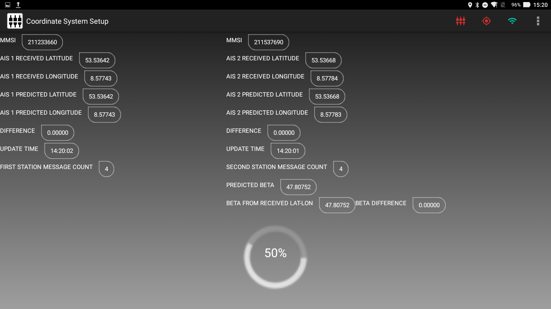

Figure . Coordinate System Setup

1. When the setup has run for INITIAL_SETUP_TIME it will stop predicting new values and you can check the differences in received and predicted values. Pressing Next will open a Dialog Box which gives you an option to rerun the setup for the same time again if you are not satisfied with the differences. If you rerun the setup the App will continue to predict new values from the previous results which can help in minimizing the differences by taking in more data points.

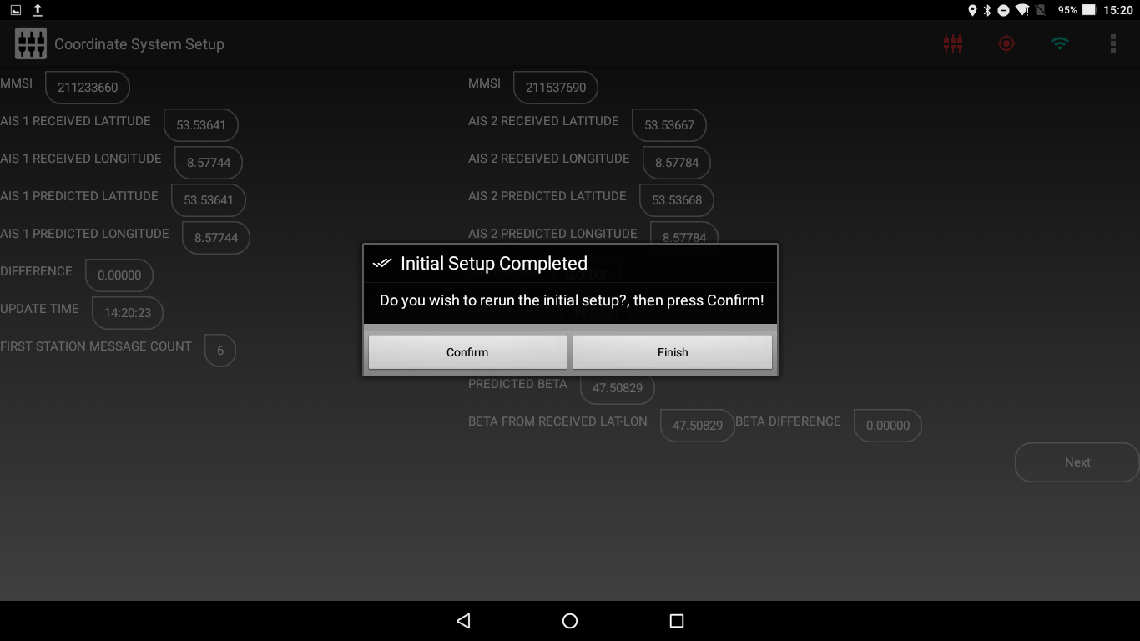

Figure . Rerun Setup if Difference is not small

1. If you are satisfied with the differences press finish on the Dialog Box and the Coordinate System for the App will be established. The App will start running the essential services of the App (Refer to System Overview).
2. The App will open the Main Dashboard and now the App can be used by the User. (Refer to Floe Navigation User Guide).

# Sync Server

For a given expedition there will always be multiple instances of the Floe Navigation App installed in multiple tablets. As administrators, you need to make sure that the Grid that the users see is same on all the tablets. To ensure this, data from each instance of the Floe Navigation App needs to be synchronized with each other. This is done using the Floe Navigation Sync Server, which consists of a Database which is very similar to the Database used by the Floe Navigation App and multiple PHP scripts which are used by the server to synchronize the data between its own database and the tablet’s database. The Sync Server uses the Internet Information Services (IIS) web server to host the PHP script. The Database is implemented using MySQL.



Figure . Floe Navigation System Application Landscape

The Database Schema of the sync server is shown in Figure 5.1.





Figure . Sync Server Database Schema

The Synchronization from the tablet to the Sync Server is explained in Chapter 6. The Floe Navigation App is also used to record Samples taken in the field. The devices used to record samples are not available by default in the Floe Navigation System and need to be added to the Sync Server which will then make those devices available on the Floe Navigation App. To add devices to the Sync Server, follow these steps:

1. Create a PUSH request containing the data of the device that you want to insert into the Sync Server. Please ensure that you specify the data according to the Schema (table: *device_list*) of the Sync Server Database as shown in Figure 5.2.
2. Call the Web Service *http://*:*/SampleMeasurement/pullDevicesFromServer.php* with the PUSH request created in Step 1. The URL will change according to the Sync Server network configuration.
3. Run the Synchronization Process as described in Chapter 6 to pull the inserted devices from the Sync Server to the tablet.

**It is recommended that you do the above steps immediately after initial configuration as described in Chapter 4.**

The Floe Navigation System can also export these samples in CSV format. To export the Samples from the Floe Navigation Sync Server, follow these steps:

1. Run the Synchronization Process as described in Chapter 6 to pull the Samples/Measurements from all the tablets to the Sync Server.
2. Call the Web Service *http://*:*/SampleMeasurement/pushSampleToServer.php*. The URL will change according to the Sync Server network configuration.

# Synchronization

To ensure that all the tablets are working with the same data, we need to synchronize them with each other using the Sync Server. The synchronization process ensures that all the important data which is used to create and maintain the coordinate system remains the same in all the tablets.

**When the coordinate system has been established on one tablet you must Synchronize that tablet with the Sync Server and pull that data in the rest of the tablets in use to set up the coordinate system in other tablets. This helps in maintaining a uniform coordinate system in all the tablets. The Device list which is used to take Sample/Measurement is also imported with the Synchronization process.**

To Synchronize a tablet with the Sync Server, follow these steps:

1. Check the parameters SYNC_SERVER_HOSTNAME and SYNC_SERVER_PORT in the Configuration Menu to ensure that they are set correctly.
2. Access the Synchronization Menu by pressing the Synchronization button on the Administrator Dashboard.
3. Please make sure that the tablet is connected to the same network as the Sync Server and not connected to a Wi-Fi network of an AIS Transponder.
4. On pressing Start Sync the app will stop its services and push the data from the internal database on the tablet to the Sync Server.

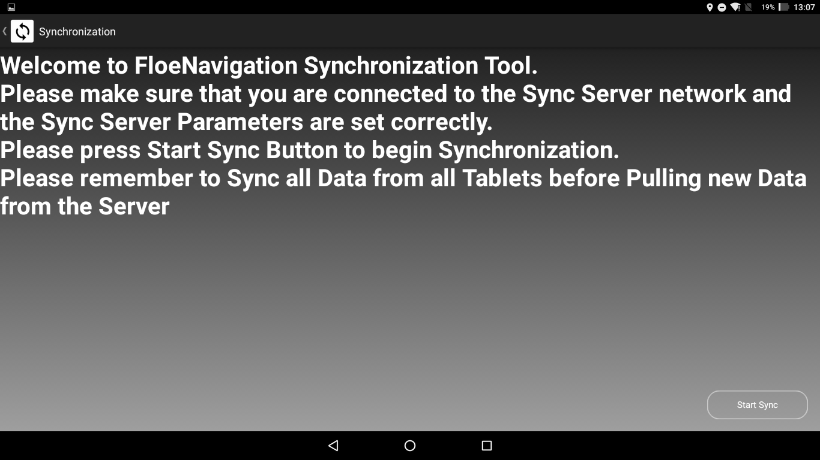

Figure . Synchronization Main Screen

If the tablet cannot find the server specified by the SYNC_SERVER_HOSTNAME it will display a message to that effect and no data will be pushed.

**Note: You can configure the server host name and the port number in Configuration Menu. Refer to** **Chapter 9** **for further details.**

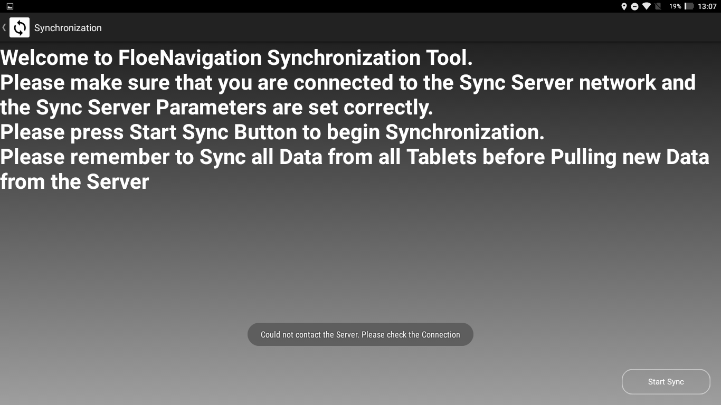

Figure . Tablet could not find the Sync Server

1. Once the data is pushed the app will wait until data from the other tablets is also pushed to the Sync Server. You should push data from the other tablets that are in operation. **It is imperative that you perform push data from other tablets before starting to pull data from the server and do not close or minimize the app or press the back button, while the app is synchronizing**.

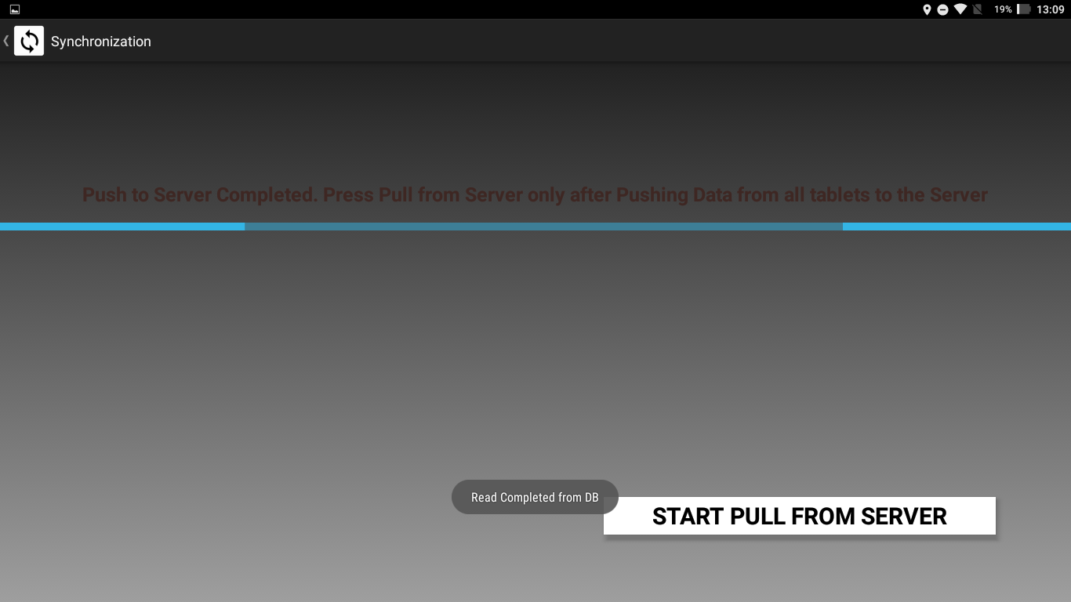

Figure . Synchronization Progress: Data Push Completed

1. Once you have pushed data from all the tablets to the Sync Server press *START PULL FROM SERVER* to start pulling the Synchronized Data from the Server. Once the data is pulled the App will restart its services and open the Administrator Dashboard. The app will now use the updated data from the Sync Server and you can now connect the app to the Wi-Fi network of an AIS Transponder once again.

# AIS Station Deployment

To deploy a new AIS Fixed Station follow these steps:

1. Press AIS Station Deployment from the Administrator Dashboard to start the deployment process.
2. Give the Station Name and MMSI, and select Station Type from the drop-down menu for the new station to be deployed on the grid and press confirm button.

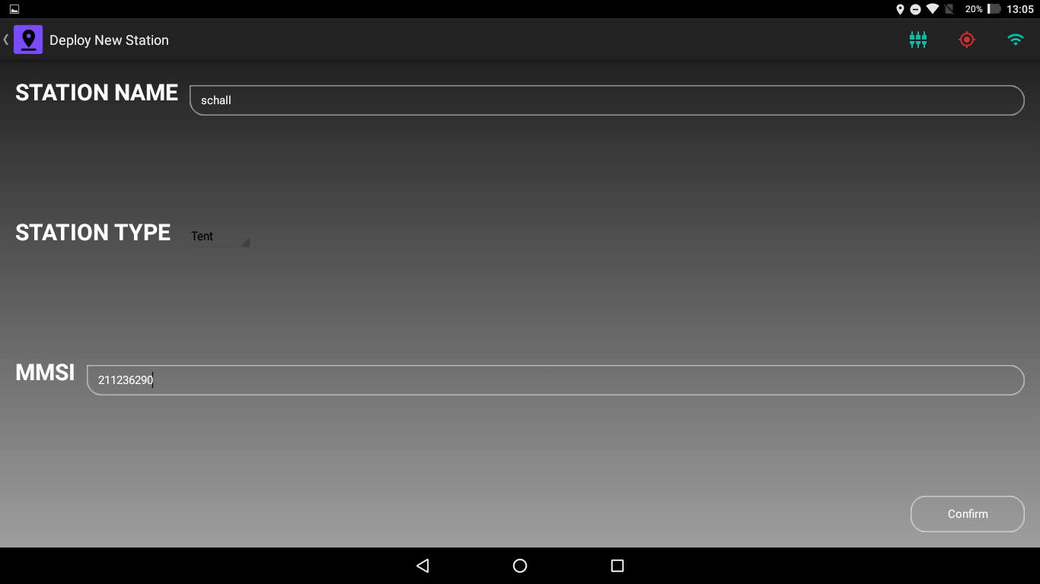

Figure . AIS Station Deployment Screen

1. If a correct MMSI number is entered and confirm is pressed the app will enter that MMSI number in its internal database and wait for a packet from the corresponding AIS Transponder.

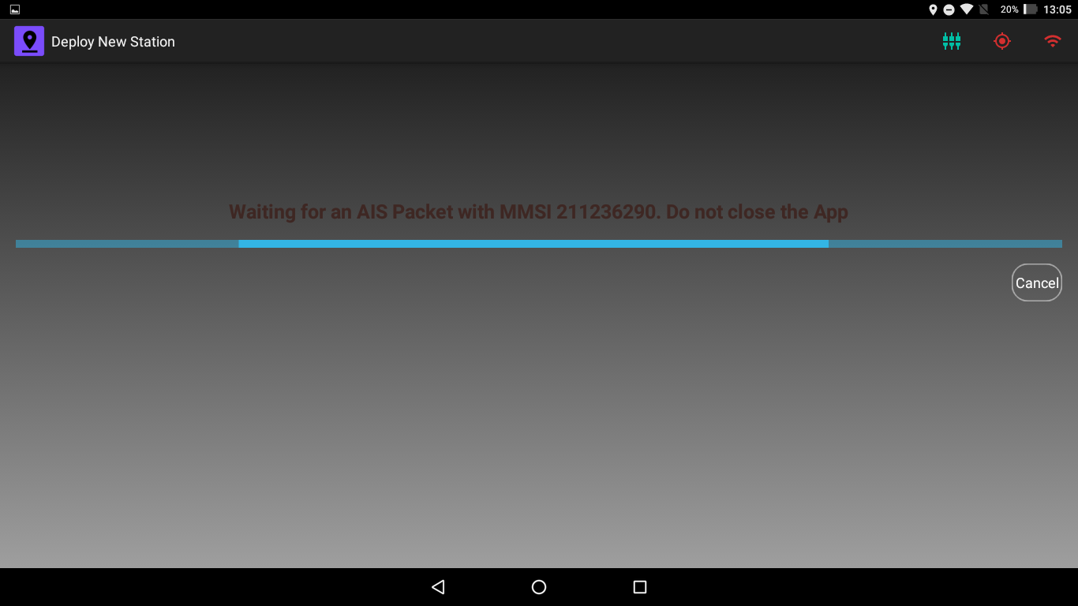

Figure . Waiting for an AIS Packet

If a packet is not received for 5 minutes or the cancel button is pressed the MMSI will be removed from the internal database and you will be redirected to Step 2.

1. When a valid packet with location data is received from the AIS Transponder, it is installed in the App as a Fixed Station and it is now visible in the Grid.

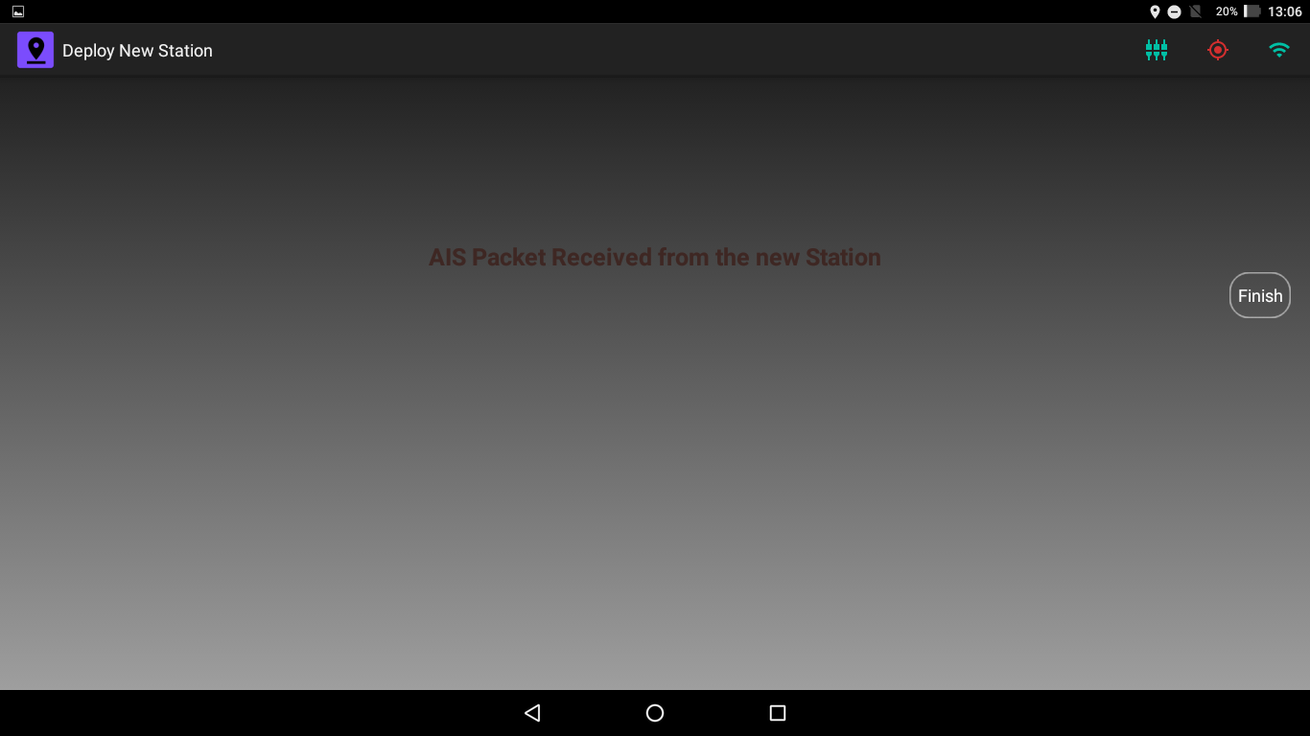

Figure . AIS Transponder Received Location Data and Installed as Fixed Station

1. Pressing Finish button will take you back to the Administrator Dashboard.

# Recovery

When a Fixed Station is no longer in use or if the Sea Ice breaks, the AIS Transponder on that position can be recovered and reused in another position. If a Fixed Station is recovered, it is no longer used to maintain the coordinate system by the app and the AIS transponder if it’s powered on, will become a Mobile Station until it is reinstalled as a Fixed Station. Similarly, a Static Station can also be removed if it is no longer useful. Fixed Station and Static Stations can only be recovered by an Administrator of the Floe Navigation App. **Please note that this process will only recover a Station from the app on the tablet in use. To reflect the change in all the instances of the app you need to Synchronize the tablets with the Sync Server as described in** **Chapter 6****.**

## AIS Station Recovery

Any AIS Station – including the origin and x-axis marker - which has been installed as a Fixed Station can be recovered by the Administrator. However, as the Floe Navigation App needs at least two Fixed Stations to maintain the Grid (as explained in Chapter 2), so if there are only two Fixed Stations installed recovery is not possible.

To recover an AIS Station follow these steps:

1. Access the Recovery Menu from the Administrator Dashboard.
2. Select the Station type as AIS Station in the Radio Button.
3. If you know the MMSI number of the AIS Station to be recovered enter the number in the MMSI field and press Recover; the app will remove the AIS Station from its Database provided there are two Fixed Stations remaining after the recovery to maintain the Coordinate System.

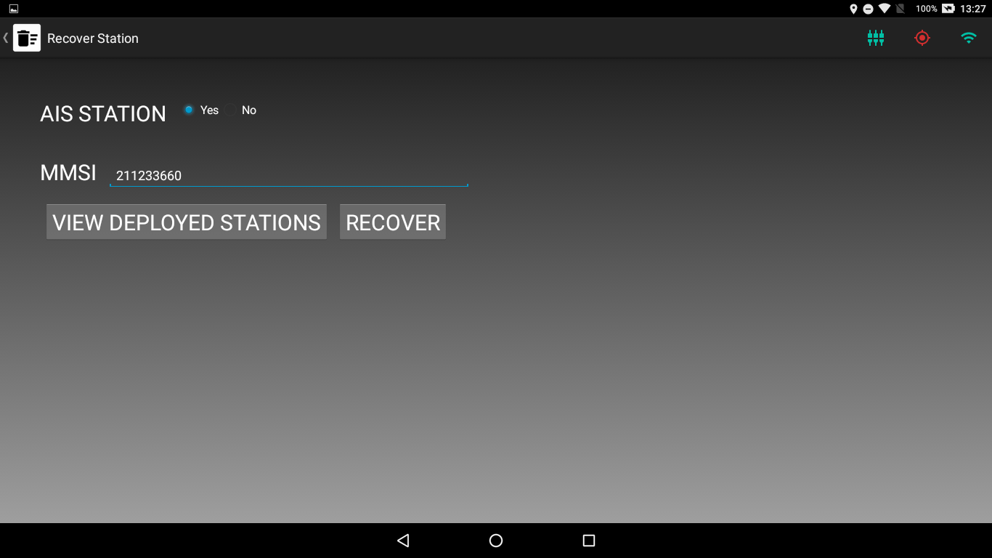

Figure . Recovery of an AIS Station using manual entry

1. In case you do not know the MMSI number of the AIS Station, press View Deployed Stations to view a list of all the Fixed Stations installed.

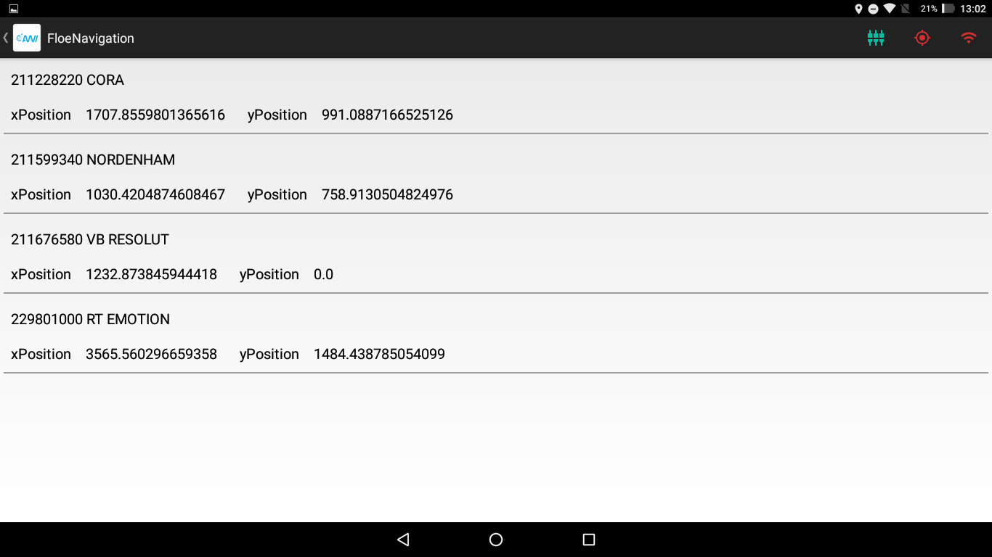

Figure . List of all Fixed Stations installed

1. Swipe right on the Station that you want to recover.

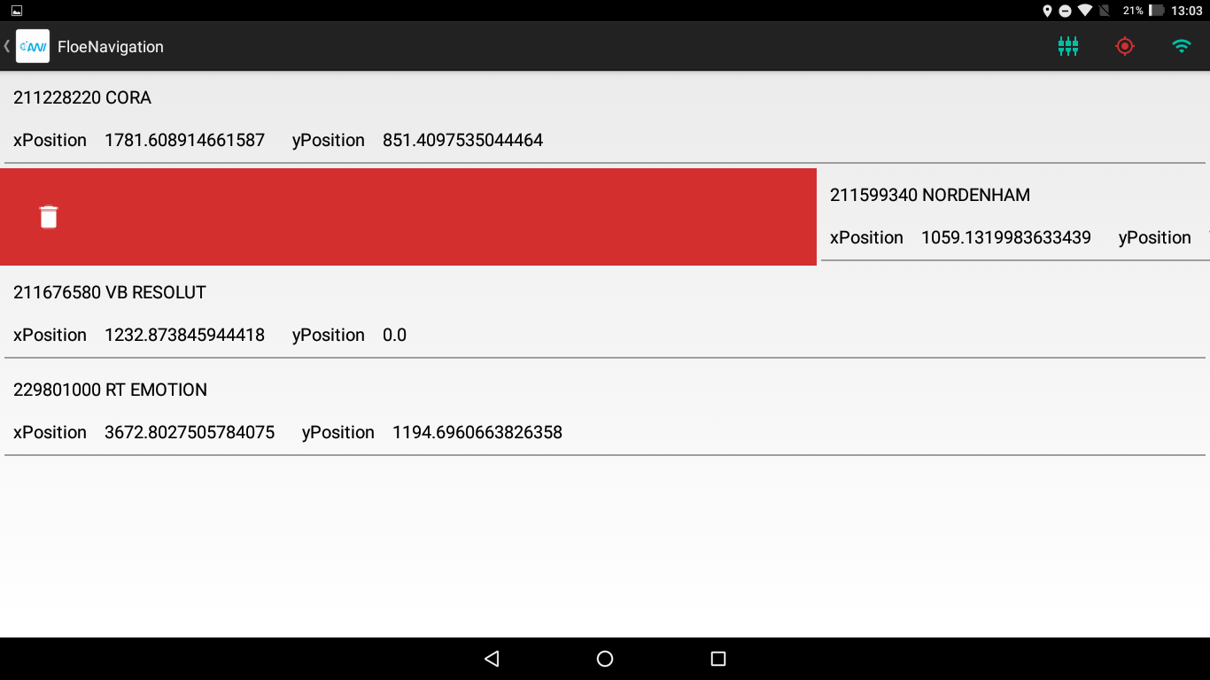

Figure . Removing an AIS Station from the List

If there are only two Fixed Stations installed the App will not recover the Fixed Station and display an error message.

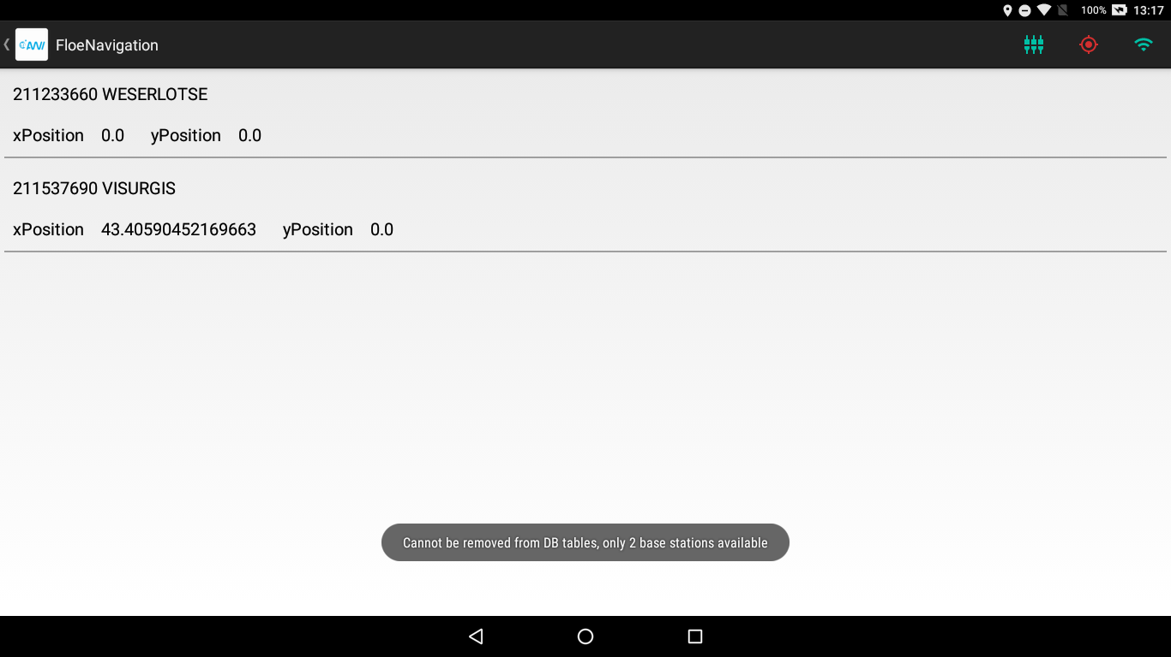

Figure . Recovery not possible if there are only two Fixed Stations installed

## Static Station Recovery

A Static Station can be recovered in a similar fashion as a Fixed Station. However, as the Static Stations are not required to maintain the coordinate system, all the Static Stations can be recovered if desired.

Follow these steps to recover a Static Station:

1. Access the Recovery Menu from the Administrator Dashboard.
2. Select the Station type as Non-AIS Station in the Radio Button.
3. If you know the name of the Static Station to be recovered enter the name in the Static Station Name field and press Recover.

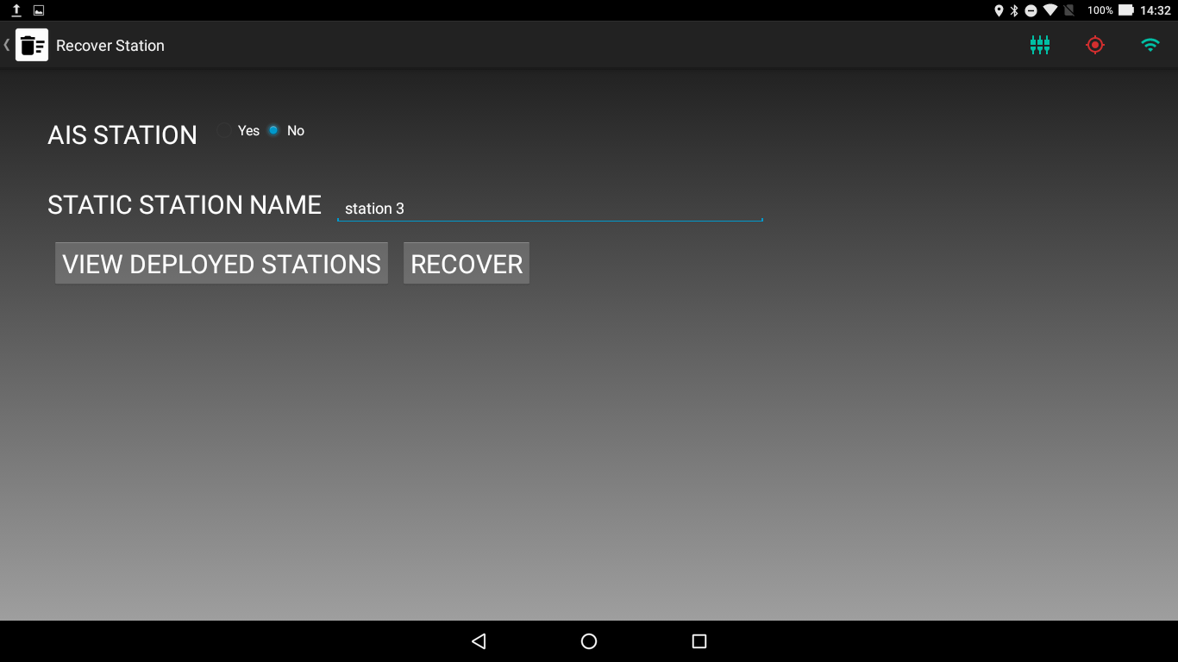

Figure . Recovery of a Static Station using Manual Entry

1. In case you do not know the name of the Static Station, press View Deployed Stations to view a list of all the Static Stations installed.

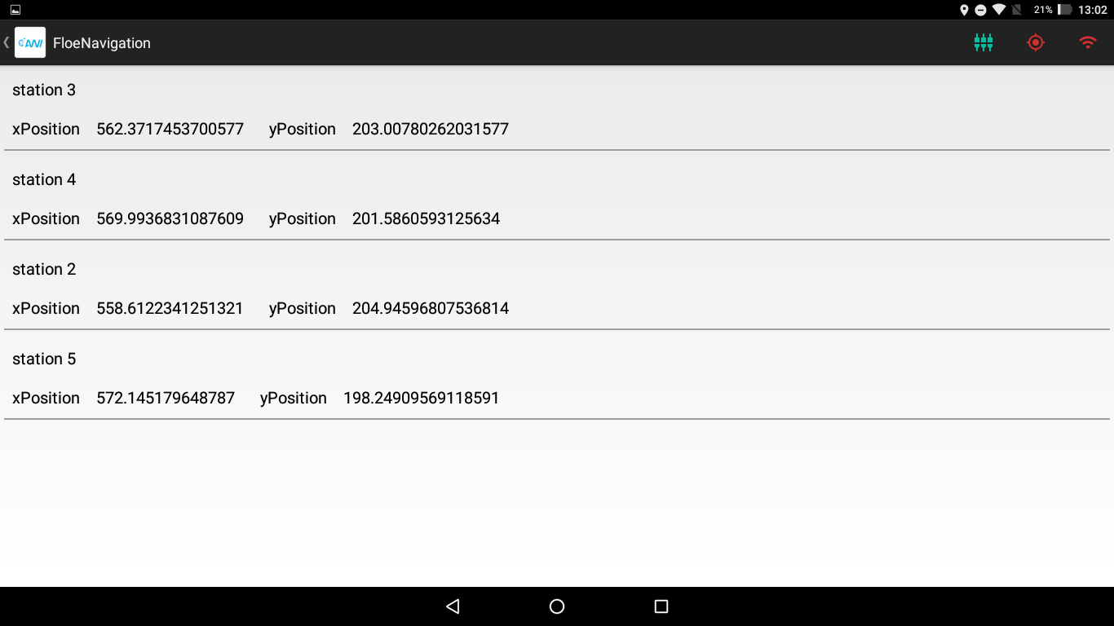

Figure . List of all Static Stations installed

1. Swipe right on the Station that you want to recover.

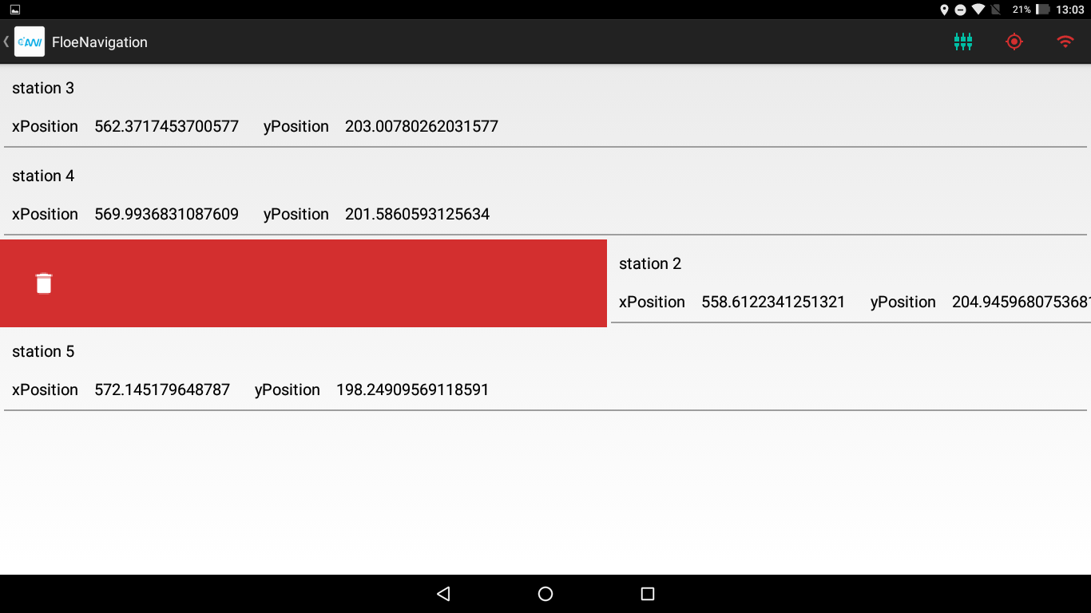

Figure . Removing a Static Station from the List

# Configuration

The Administrator can configure certain internal parameters of the Floe Navigation. It is recommended to check these parameters before the Initial Grid Configuration (as described in Chapter 4) and before and after each Synchronization (as described in Chapter 6) to ensure that these parameters are set correctly and consistent in all instances of the App installed in all tablets.

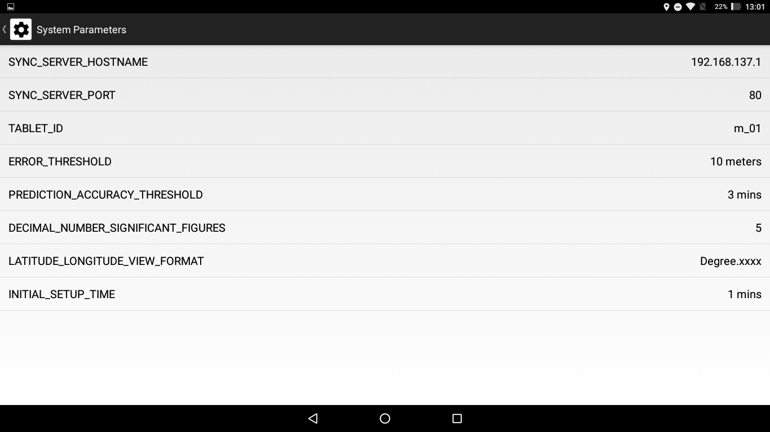

Figure . Configuration Parameters in Floe Navigation App

## Parameters

The details of each parameter are shown in the table below:

Table . List of Configuration Parameters

|  |  |  |  |  |
| --- | --- | --- | --- | --- |
| **Parameter Name** | **Description** | **Default Value** | **Range** | **Synchronized** |
| ERROR_THRESHOLD | Defines the threshold in meters between the Predicted Location and the Received Location for a Fixed Station for the Prediction to be considered incorrect. Used by Validation Service to detect breakage of Sea Ice | 10 meters | 0 – 100 meters | ✔ |
| PREDICTION_ACCURACY_THRESHOLD | Defines the time during which if a specific number of predictions for a Fixed Station are beyond the ERROR_THRESHOLD value, that Fixed Station is considered to be broken from the Sea Ice | 15 minutes | 10 – 60 Minutes | ✔ |
| LATITUDE_LONGITUDE_VIEW_FORMAT | Sets the format of Geographic Coordinates in the App. | Decimal (Degree.xxxx) | Decimal or Degree Minutes Seconds | ✖ |
| DECIMAL_NUMBER_SIGNIFICANT_FIGURES | Sets the number of significant figures to be displayed in the app. | 5 | 0 - 10 | ✔ |
| INITIAL_SETUP_TIME | Defines the time for which the initial setup should run | 30 minutes | 10 – 60 minutes | ✔ |
| SYNC_SERVER_HOSTNAME | Sets the hostname/IP of the Sync Server | 0.0.0.0 |  | ✔ |
| SYNC_SERVER_PORT | Set the Port number of the Sync Server | 80 |  | ✔ |
| TABLET_ID | Sets a unique ID of the tablet which is appended to all the waypoints created on the tablet. |  |  | ✖ |

## Editing Configuration Parameters

To update the value of a configuration parameter, access the Configuration menu from the Administrator Dashboard. Select the Parameter from drop-down list.

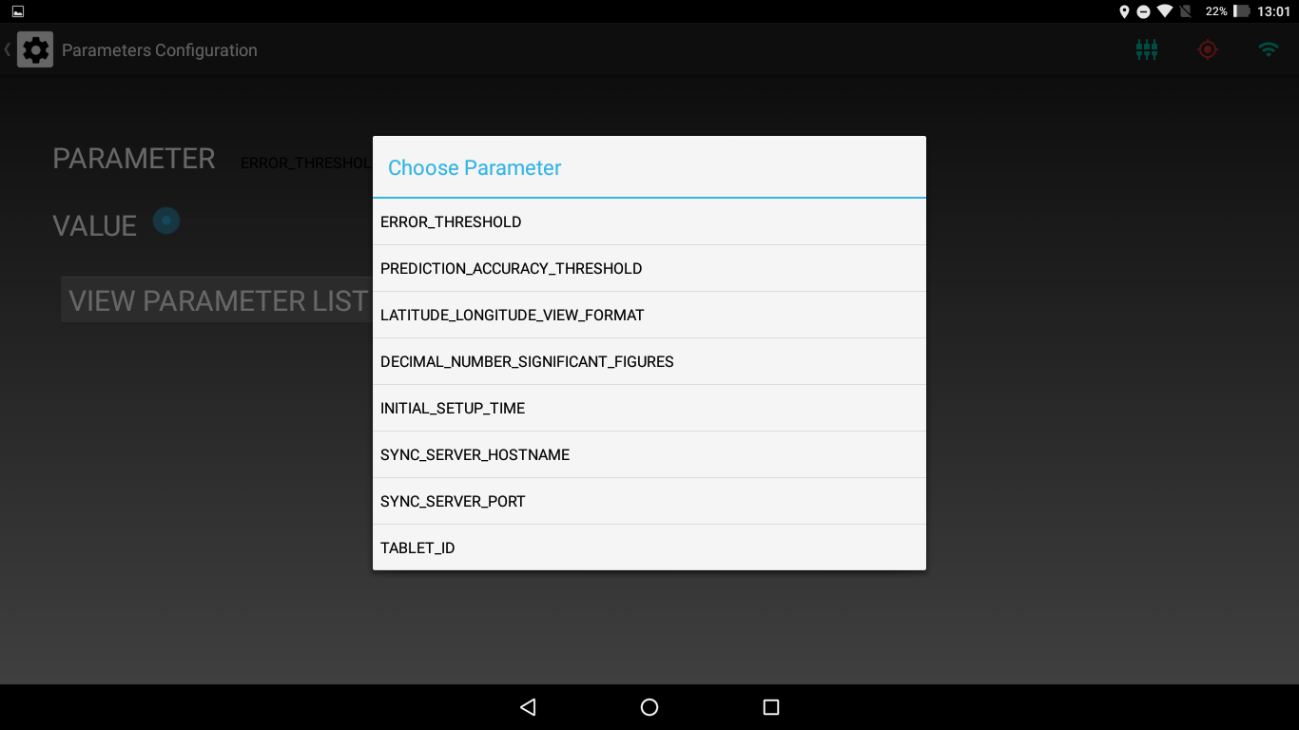

Depending on the parameter selected the app will give you options to set a new value for the parameter.

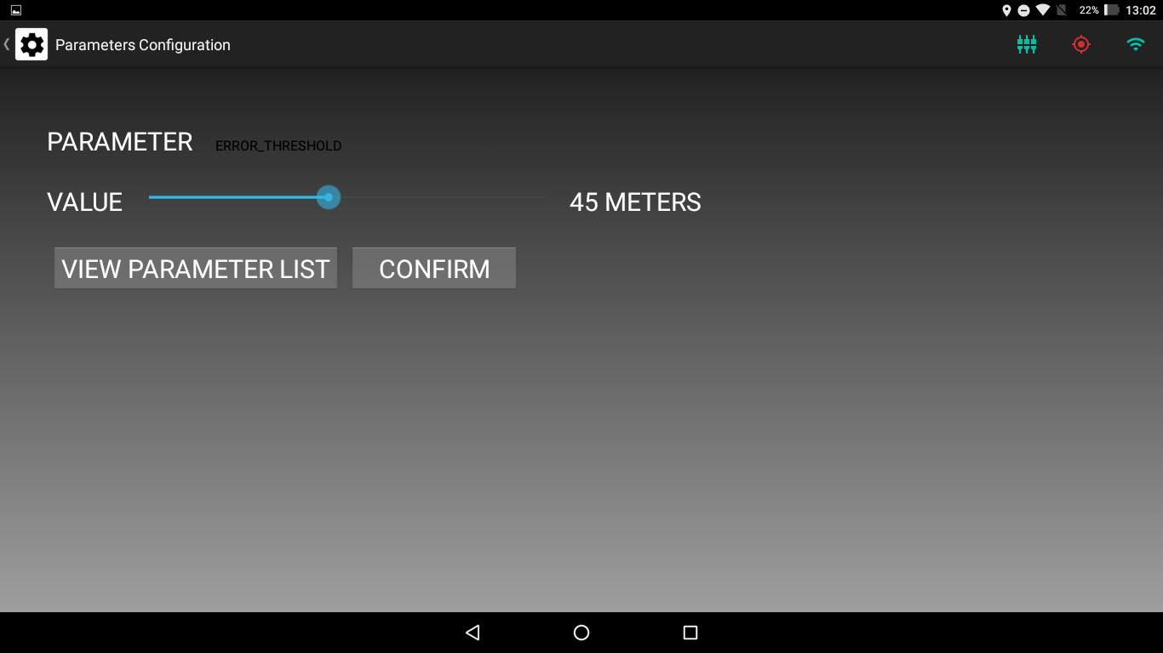

Figure . Editing Parameter Value

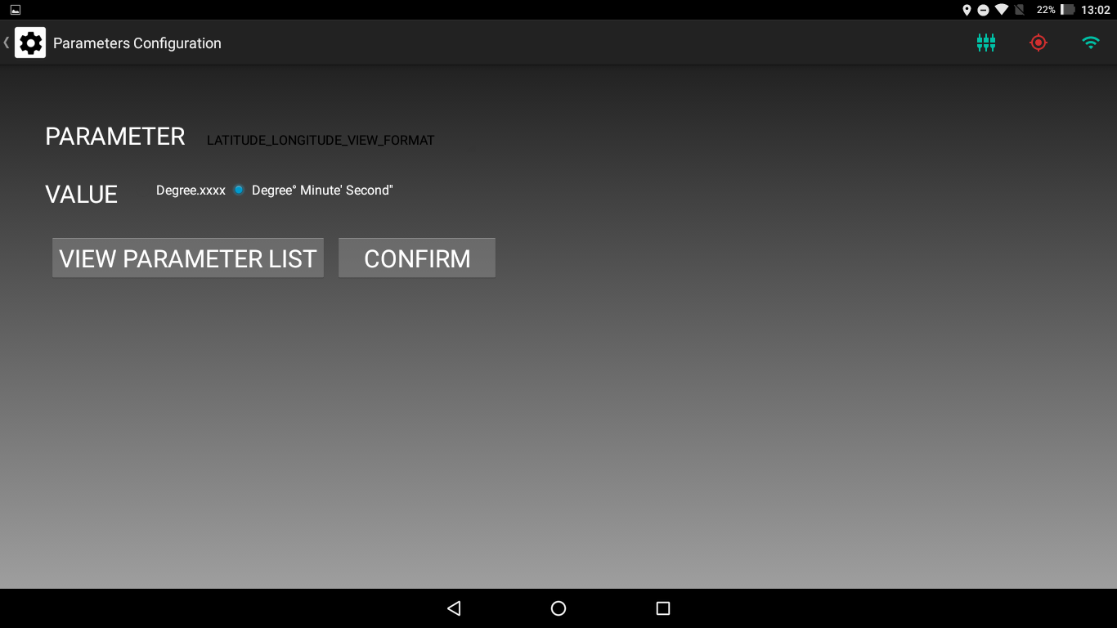

Figure . Another Example of Updating Parameter

# User Administration

You can add or remove other Administrators using the Administrator Privileges Menu.

To add a new administrator, access the Administrator Privileges menu and type the Username and Password in their respective field and press confirm.

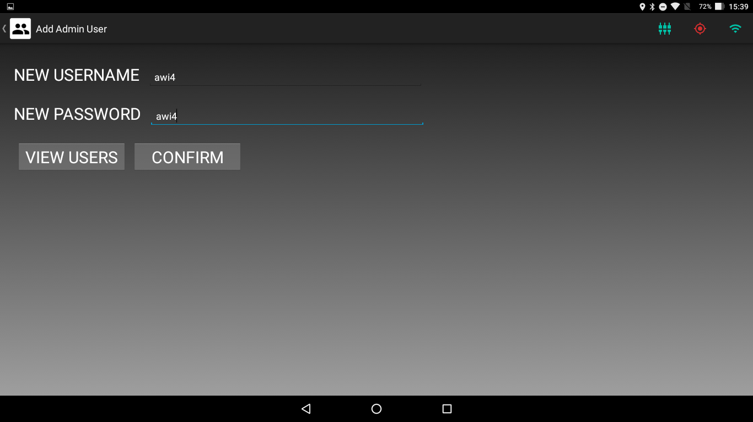

Figure . Administrator Privileges Menu

Press View Users to view a list of the existing Administrators

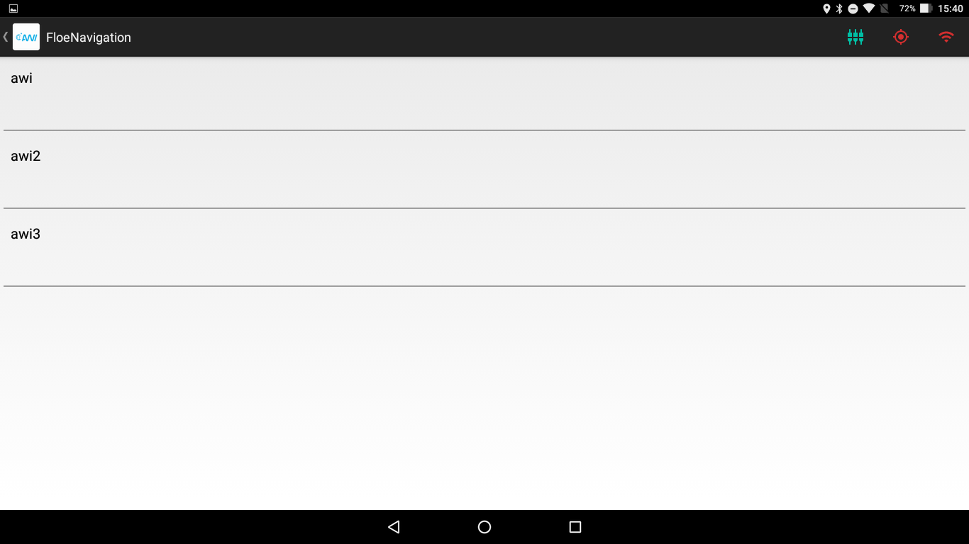

Figure . List of Administrators

To remove an administrator just swipe right on the list.

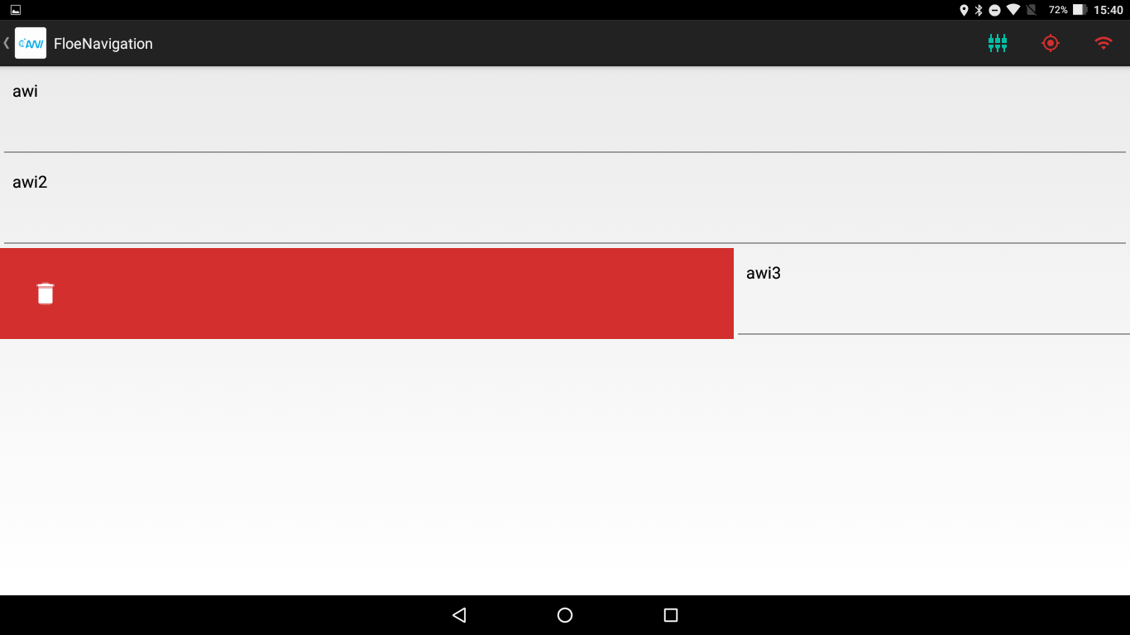

Figure . Removing an Administrator from the List

It is not possible to remove all administrators, as the app requires at least one administrator.

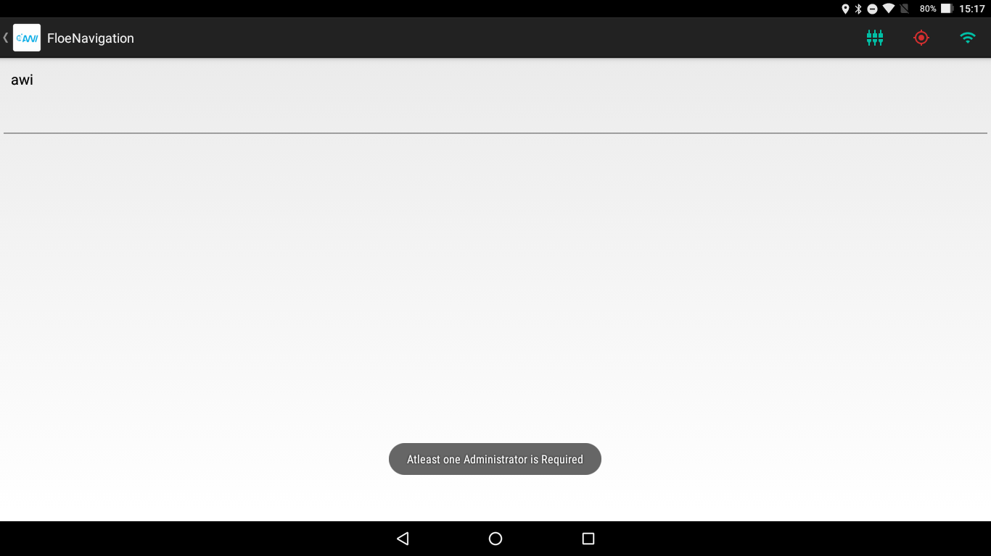

Figure . At least one Administrator is Required